•        More segregated (Actually more uneven)

The 1 group version of the segregation index, D, is used. This is called IS or the segregation index in geosegregation analyser, but is algebraically identical to D.

D values range from 0 to 1, with 0 indicating no segregation, and 1 indicating complete segregation. Therefore increases between the two censuses indicate more segregation.

•        More isolated

The correlation ratio, Eta2, was used. This is a modification of the other indicator in this dimension, the Isolation index, which corrects for different minority and majority population sixes.

For Eta2, scores can vary from 0 to 1. Higher scores indicate greater isolation, lower scores less segregation, therefore increases in the score between two censuses mean greater isolation over time. A simple illustration is shown below.

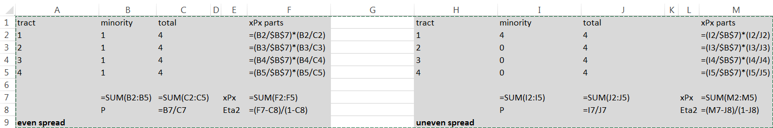



•        More dense

The absolute concentration index, ACO, was used. This produces a value from 0 to 1 which attempts to summarise the preference for the minority group to live in geographically concentrated areas. A score of 1 indicates the greatest theoretically possible level of spatial concentration for a minority group, i.e. a preference for density; and a score of 0 indicates the greatest theoretically possible level of spatial deconcentration for a minority group, i.e. an aversion to density.

An increase in the score between the two censuses therefore indicates an increasing preference for spatial density.

•        More clustered

The absolute clustering index, ACL, was used. This is a measure of the proportion of a total minority population in different tracts weighted upwards by the presence of members of that minority group in contiguous tracts (in geosegregation analyser and most GIS programs; a slightly different approach based on distance between centroids was used to weight in Massey & Denton 1988), and adjusted by total population size to fit on a 0-1 scale. Higher scores mean more clustered; lower scores mean less clustered.

•        More central

The absolute centralisation index, ACE, was used. Unlike the other indices the possible values of this index vary from -1 to +1, and attempts to summarise the relationship between where a minority group lives and a city or regional centre. Intuitively, positive values can be interpreted as meaning that the city centre ‘attracts’ the minority population, with a greater preference for living near to rather than far from this centre; and negative values can be interpreted as meaning the city centre ‘repels’ the minority population, with a greater preference for living further rather than closer to this centre. Values at and near to zero indicate that the city centre appears to have no influence on the spatial distribution of the minority population.

Increases in the index from 2001 to 2011 therefore mean either that a minority group has become ‘more attracted’ or ‘less repelled’ by the city/regional centre between the two censuses.